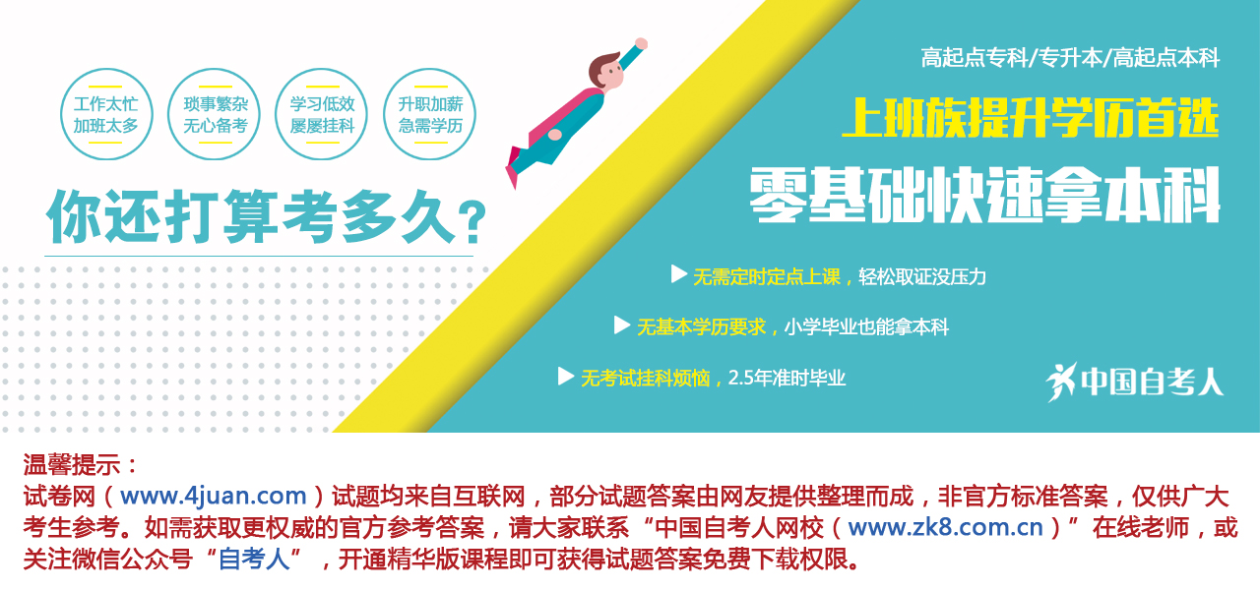

全国2012年1月自学考试电子商务英语试题
课程代码：00888
请将答案填在答题纸相应位置上
一、词汇和语法（本大题共20小题，每小题1分，共20分）
根据句子的意思选择一个正确的答案，错选、多选或未选均无分。
1. My shoes are similar to _________ you had on yesterday.
A. the one B. the one which
C. the ones what D. the ones
2. My dentist appointment is on Friday, _________.
A. fifth October B. five October
C. the fifth of October D. the five of October
3. They got there _________ we by 20 minutes.
A. more early as B. earlier than
C. as early as D. more earlier than
4. I’ll go and see the exhibition as soon as I _________ the recorder fixed.
A. have got B. will have got
C. will get D. had got
5. The radio _________ by my son just now.
A. has been repaired B. is being repaired
C. repaired D. has repaired
6. _________ pure lead, the lead ore is mined, then smelted, and finally refined.
A. Obtaining B. Being obtained
C. To obtain D. It is obtained
7. He _________ in London by eleven o’clock, but he started too late.
A. should be B. ought to have been
C. must have been D. might have been
8. I wish I _________ back home; I don’t like this place.
A. am B. have been
C. were D. shall be
9. The business would be a success, _________ owned it.
A. who B. whose
C. which D. whoever
10. Either the shirt or the sweater _________ suitable for this season.
A. is B. are
C. have been D. has
11. I keep my reference books near my desk for _________.
A. convention B. convenience
C. conference D. confidence
12. She decided not to _________ her husband’s name when she got married.
A. adore B. adopt
C. admire D. admit
13. Passing the English examination should _________ your chances of getting the post.
A. develop B. improve
C. advance D. enhance
14. They’ve _________ the prices in the shop, so it’s a good time to buy.
A. deduced B. decreased
C. reduced D. lessened
15. I was on the _________ of accepting.
A. border B. tip
C. verge D. side
16. Frequent cultural exchanges will certainly help _________ friendly relations between our two universities.
A. feed B. support
C. foster D. tend
17. We can visit your company on Monday or Tuesday; our plans are fairly _________.
A. flexible B. elastic
C. supple D. compliant

18. How I wish to _________ in your sufferings.
A. enter B. contribute
C. participate D. provide
19. We must make _________ efforts to improve things.
A. heavy B. thick
C. massive D. large
20. Einstein’s new theory on optics changed _________ scientific ideas about light.
A. technical B. original
C. classical D. mechanical
二、完形填空(本大题共10小题，每小题1分，共10分)
从选择项中选择一个最适合短文的选项，错选、多选或未选均无分。
Koalas look like teddy bears, ___21___ they are not bears at all. They are really animals called marsupials.
These animals carry their young in pouches, like kangaroos ___22___ .
Koalas live in the forests of Australia. They spend most of their lives in eucalyptus trees. They ___23___ never come down even for a drink of water. In fact, their names means “no drink.” The koalas have a ___24___ of knowing which trees they can feed on safely. They eat each leaf the same way. ___25___ , they bite the leaf off the stem and then they chew it from base to ___26___ .
When a koala is born, it is less than an inch long. The baby crawls into the mother’s ___27___ right away and stays there for six months. After that, the baby rides piggyback or hangs on ___28___ the mother’s front paws and legs. Young koalas stay with their mothers for at least a year.
The koala is a strong climber. Its paws end with sharp claws, ___29___ he can get a good grip on tree branches. Koalas sleep in the eucalyptus trees on most of the day and eat at night. Koalas may live alone or in small ___30___ . Males sometimes use their sharp claws as weapons. Most of the time, koala families live together peacefully.
21. A. while B. but C. when D. however
22. A. carry B. do C. doing D. carrying
23. A. nearly B. hardly C. rarely D. scarcely
24. A. means B. manner C. way D. point
25. A. However B. Whatever C. First D. Notwithstanding
26. A. foil B. top C. tip D. end
27. A. breast B. bosom C. pouch D. heart
28. A. along B. between C. off D. by
29. A. and B. as C. so D. because
30. A. amount B. number C. groups D. deal
三、 阅读理解（本大题共10小题，每小题2分，共20分）
阅读下面的短文，从A、B、C、D四个选项中选出一个最佳答案填空或答题，错选、多选或未选均无分。
Passage 1
In the United States, boys and girls start school when they are five years old. In some states they must stay in school until they are sixteen. Most students are seventeen or eighteen years old when they graduate from secondary schools. Another name for secondary school is high school.
Most children go to public elementary and secondary schools. The parents of public school pupils do not have to pay directly for their children’s education because tax money supports the public schools. If a child attends a private school, his parents pay the school for the child’s education.
Today about half of the high school graduates go on to colleges and universities. Some colleges and universities receive tax money from the government. A student at a state university does not have to pay very much if his parents live in that state. Private colleges and universities are expensive; however, almost half of the college students in the United States work while they are studying. When a student’s family is not rich, he has to earn money for part of his college expenses.
31. The students in all the states of the U.S. must finish _________ school until they are _________ at least.
A. high; eighteen B. elementary; seventeen
C. secondary; sixteen D. starting; five years old
32. The tax money from the states supports the public schools, doesn’t it?
A. Yes, it doesn’t B. No, it does
C. Yes, it does D. No, it doesn’t
33. According to the text, a child in the U.S. can enter a college or a university only _________.
A. at the age of eighteen B. before completing elementary school
C. before graduating from public school D. after finishing secondary school
Passage 2
Music which is original is individual and personal. That is to say, it can be identified as belonging to a particular composer. It has particular qualities, or a style, which are not copied from another. If you can recognize the style of a composer, you will probably be able to tell that a certain composition belongs to him or her even though you have never heard it before. A composer organizes his melodies (旋律) and rhythms and combines sounds to create harmony. He may be capable of thinking up very good, original tunes, yet if tunes are poorly organized, the final result will not be to standard.
Good music expresses feelings in a way that is suitable to those feelings. There may be joy, sorrow, fear, love, anger, or whatever. Bad music, on the other hand, may confuse unrelated feelings, it may not express any important feeling at all, or it may exaggerate some feelings and make them vulgar, that is, cheap and ugly.
Good music will stand the test of time. It will not go out of fashion but will continue to be enjoyed and respected long after it is first introduced. It will gain a kind of permanent status while bad music will disappear and be forgotten quickly. In pop music, where the general rule seems to be “the newer the better”, the test of time is the hardest test of all to pass.
34. A piece of original music _________.
A. has a personal style
B. sounds very familiar to our ears
C. is one whose style you cannot recognize
D. cannot be recognized as belong to any composer
35. Good music is _________.
A. well-organized tunes. B. the proper expression of feelings.
C. an expression of mixed feelings. D. exaggeration of some feelings.
36. The passage is concerned with _________.
A. how to compose music B. how to enjoy music
C. how to judge music D. how to perform music
Passage 3
Personal interviewing (面试) is most effective when all the people to be interviewed are located in a relatively small geographical area. Otherwise, the time and expense spent in traveling from one person to another makes this type of interviewing economically impractical. Personal interviewing is usually used when the information needed is too complex to be gathered by another technique. For example, a problem being studied may require the interviewer to probe beyond the more superficial answers that might be obtained with another method.
It is sometimes assumed that personal interviewing is the most accurate of all survey research techniques. Although personal interviewing may be accurate in many cases, human errors may prevent a researcher from obtaining valid results. Questions perceived by the interviewee(应试者) as an invasion of privacy or threatening in any way will probably produce false or partially true answers. Also, since the interviewer（面试者）must interpret the respondent’s statements, a certain amount of information loss results even though the respondent may be answering truthfully.
In spite of the problems, at least two major advantages are provided by this research technique. First, the alert interviewer can generally tell if the respondent is being truthful or if he or she is giving superficial or untrue responses. Second, the interviewer can rephrase questions, give more explanation, or probe more deeply if the initial questions do not produce the information desired. As a result, the information gleaned should be more accurate than that provided by interviews where no one is present to clarify questions or to interpret answers.
37. Sometimes a researcher cannot get valid results because _________.
A. the information needed is too complex to be gathered
B. personal interviewing is the most accurate of all survey research techniques
C. personal interviewing is not as effective as other research techniques
D. both interviewer and interviewee may make mistakes during the interviewing
38. In the second paragraph, the phrase “an invasion of privacy” most probably means _________.
A. an unpleasant conversation
B. a challenge to interviewee’s professional skills
C. an interference with interviewee’s personal affairs
D. an interference with interviewee’s hobby
39. In the first sentence of the last paragraph, the pronoun “this” refers to _________.
A. survey B. question
C. answering D. personal interviewing
40. According to the last paragraph, one of the advantages of the personal interviewing is _________.
A. the interviewer can ask the interviewee questions again in different ways
B. the interviewer can ask the interviewee some personal questions
C. the initial question does not produce the information desired
D. no one is present to clarify questions
四、单词汉译英（本大题共15小题，每小题1分，共15分）
根据给出的汉语词义和规定的词类写出相应的英语单词。每词的部分字母已给出。请将整个单词写在答题纸上。
41. 轮廓；纲要n. o_ _ line
42. 报答，报偿，奖赏 n. & v. r _ w_ _ d
43. 地方；位置 n. loca _ _ _ _
44. 整理；安排v. arr _ _ ge
45. 技术员；工艺师 n. techni _ _ _ _
46. 尝试，试图，努力 v. att _ _ p _
47. 可用的，可获得的 adj. av _ _ l _ ble
48. 放弃；遗弃 v. aban _ _ _
49. 卖主，卖方 n. v _ _ dor
50. 估计 v. & n. esti _ _ _ _
51. 分类；归类 v. cla _ _ _ fy
52. 流行；货币 n. c_ rr _ _ _ y
53. 登记，注册 v. & n. re_ _ _ ter
54. 做广告 v. ad _ _ _ tise
55. 自动的 adj. au _ _ _ _ tic
五、单词英译汉 （本大题共15小题，每小题1分，共15分）
给出下列单词或术语的汉语意思。
56. client
57. onetime startup fee
58. realtime communication
59. credit card
60. account data
61. direct billing
62. web page
63. intelligent search engines
64. legal counsel
65. human resources
66. consumer protection law
67. joint venture
68. supply chains
69. information network
70. global market
六、英译汉 （本大题共5小题，每小题2分，共10分）
阅读下面的短文，然后把划线的句子翻译成汉语。
Making the transition to e-business can be daunting. (71) There is so much to do, so many questions to answer, so many possibilities to explore. How do you know where to start?
(72) When you begin planning an e-business, the most important thing to remember is that you shouldn’t try to do everything at once. Biting off more than you and your team can effectively handle can be as big a problem as doing nothing. Focus your initial ebusiness efforts on those areas that can most immediately gain from the investment. (73) This lets you pick a targeted starting point, with clear goals and boundaries, so you can build the foundation from which other e-business initiatives will flow.
Intel took this advice to heart when it began planning the Intel e-business Web site. Rather than attempting to remake the entire Intel business infrastructure — a truly daunting task for a global corporation with over 65,000 employees — the company focused on its direct customers, including OEMs and distributors. (74) The idea was to focus on customers who already had a relationship through Intel field sales and customer support, and find ways to improve that relationship through the Internet.
(75) “We picked one thing we could build very quickly and deploy to our customers,” says Sandra Morris, director of Intel’s Internet Marketing & e-Commerce.
七、汉译英 （本大题共5小题，每小题2分，共10分）
用括号内给出的词，把下列汉语句子翻译成英语。
76. 工业革命改变了整个英国的社会结构。（modify, structure）
77. 我们必须尽最大可能地利用我们已有的资源。（make use of, resources）
78. 由于天气原因，航班已经推迟了一个小时了。（due to, delay）
79. 我们怎样才能防止这种疾病蔓延？（prevent ... from, disease）
80. 供水条件的改善会给健康带来巨大的影响。 （water supply, have an effect on）



